**­­Environment installations:**

* intel realsense sdk
* python wrappers for intel realsense sdk.
* OpenCV for python

**Progress**:

We have a Python script that breaks .bag file to depth/color, aligning them to one frame(to color) then saving it, and saving csv for each frame.

**Pose estimation algorithms:**

1. Cubemos - <https://www.cubemos.com/skeleton-tracking-sdk>

* no depth. 2d

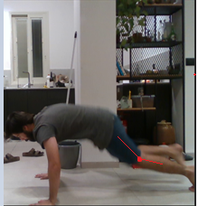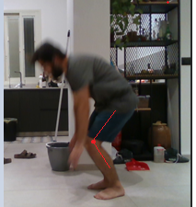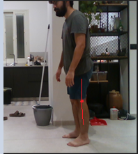Burpee video

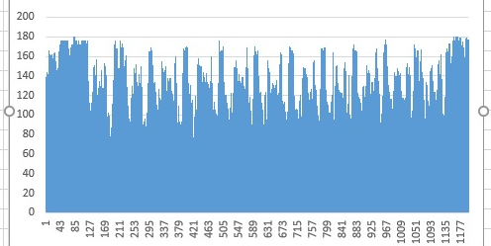

Left leg, knee angle. ­­­

1. OpenPose - <https://github.com/CMU-Perceptual-Computing-Lab/openpose>

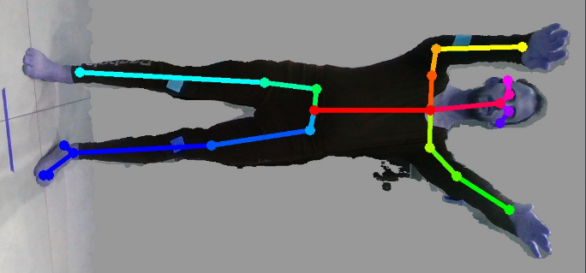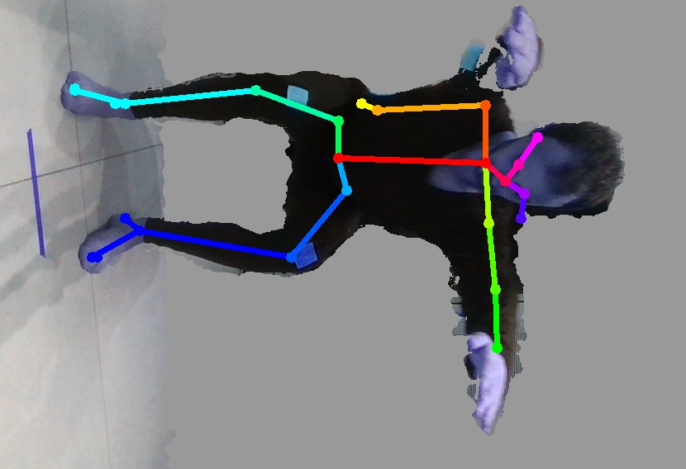Due to poor accuracy, as you can see, we decided to switch to a more accurate algorithm - AlphaPose

1. AlphaPose - <https://github.com/MVIG-SJTU/AlphaPose>

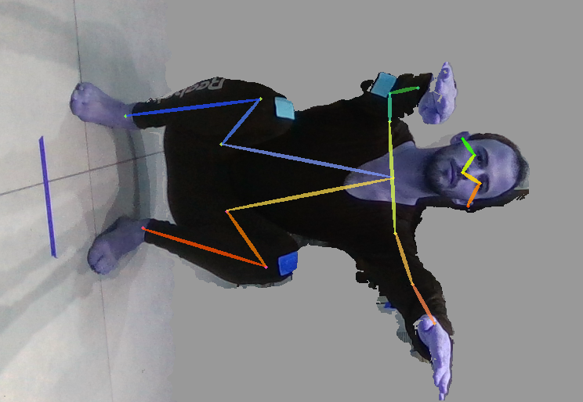Using AlphaPose yielded more accurate result for body skeleton key-points.

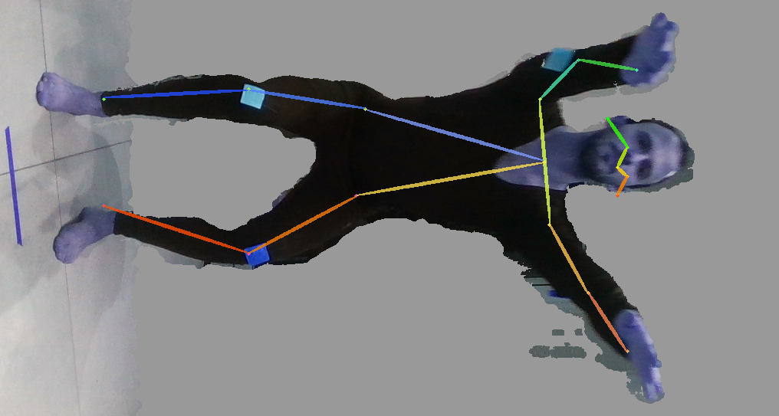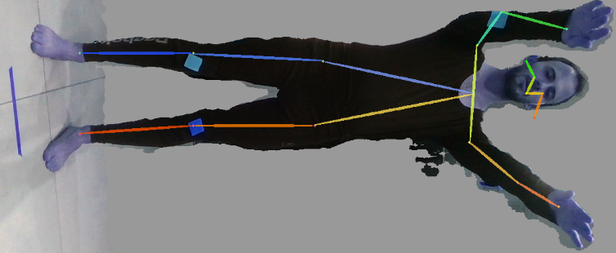

After discussing the specifications with Mayaan, we were still missing some key body points. We needed model with different skeleton key points. So we switched the “FastPose” model to “Halpe” model:

